IBA eHIS 10.x - eMail Interface
Installation and Configuration
Table of Contents

1. Introduction 3
2. MAIL Hardware, Software Requirements 4
2.1. Mail Software Requirements 4
2.1.1. Launch Express ClickYes 4
2.2. Email Server System Requirements 5
3. Installation and Configuration 6
3.1. Email Interface Gateway Installation and Configuration 6
3.1.1. Installing IBAeHIS Email Interface Gateway 6
3.1.2. Configuring ODBC 6
3.1.3. Configuring MDB 8
3.1.4. Setting up Parameter for IBA Email Service 12
3.1.5. Example ‘PARAM’ table entry 14
3.1.6. Start the Mail Service 14
3.1.7. Test Mail through Mail Manager Service window 15
3.2. PDF Creation Utility Installation and Configuration 16
3.2.1. Installation requirement for PDF Creation Utility 16
3.2.2. Setting up Environment Variables 16
3.2.3. Configuring ODBC 17
3.2.4. Workstation Parameters configuration 20
3.2.5. PDF Creation Utility Process Starting 21
3.2.6. PDF Creation Utility Trouble Shooting 23

CHAPTER
1

Introduction

This document explains the Hardware, Software requirement for eMail and explains the configuration details.

CHAPTER
2

MAIL Hardware, Software Requirements

Mail Software Requirements
Sending out the email from IBA eHIS is using Microsoft Outlook. Currently IBAeHIS uses Messaging Application Programming Interface (MAPI) for emailing IBAeHIS ports.

Note: MAPI is a set of functions that mail-enabled and mail-aware applications use to create, manipulate, transfer, and store mail messages. It gives application developers the tools to define the purpose and content of mail messages and gives them flexibility in their management of stored mail messages.

Launch Express ClickYes

Mail Server (SMTMLSRV.EXE) uses MAPI controls to send mail. Due to enhanced security model of Microsoft Outlook, Microsoft Outlook will pop-up the following message for each mail being sent.
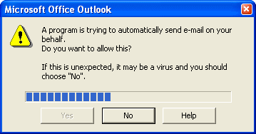
Figure 4-1
To avoid this pop-up, use freeware tool namely “Express ClickYes”. Express ClickYes is a tiny program that runs in the system tray and automatically clicks the Yes button for the Outlook security prompt that asks you to confirm mail sending from third party applications or access to Outlook's address book.

Note: Express ClickYes does not acknowledge for any other prompts.

Email Server System Requirements

IBAeHIS recommends a dedicated system with the following configuration as minimum system requirements for IBAeHIS Email Interface Gateway and PDF creation Utility (Further referred to as IBAeHIS_EMAIL_GATEWAY).

Hardware Requirements
Hardware Item | Requirement
CPU | An IBM compatible PC with a Pentium 4 processor or better (Pentium IV with 2.8 GHz recommended)
Memory | 512 MB or higher
Disk Space | 20 GB or higher
Media Device | CD-ROM drive functioning as a logical drive. Required during installation time only

Software Requirements
Software Item | Requirement
Operating System | Windows 2000 with Service Pack 3  Windows XP with Service Pack 2
Microsoft Components | Microsoft Outlook 2000 or 2003  Microsoft Access 2000 or 2003
Others | IBAeHIS Email Service1  Office XP (Word, Access)  Oracle Forms software as per details provided in eHIS Installation.  JDK 1.5 or 1.5 above
.

CHAPTER
3

Installation and Configuration

This section describes the system requirements and installation steps to be followed for enabling mail interface and PDF Creation Utility.

Email Interface Gateway Installation and Configuration

This section describes the system requirements for IBA_EMAIL_GATEWAY and installation steps to be followed for enabling email interface.

Installing IBAeHIS Email Interface Gateway

Do the following in IBAeHIS_EMAIL_GATEWAY system:

- Create the sub-directory ‘IBAEHIS\SMTMLSRV’ under C: drive (if not exists)
- Share the sub-directory ‘SMTMLSRV’ and specify the share name as ‘SMTMLSRV’
- Copy the supplied file ‘SMTMLSRV.MDB’ to the sub-directory ‘IBAEHIS\SMTMLSRV’
- Ensure the MSMAPI32.OCX file is available in the C:\winnt\system32 folder and has to be registered (Local Administer Privilege required)
  - Command – Go to C:\winnt\system32, type REGSVR32 MSMAPI32.OCX and run.

Configuring ODBC

IBAeHIS Email Service and PDF Creation Utility that is running in IBA_EMAIL_GATEWAY system should be able to read email requests from IBA database. For this purpose, ODBC should be configured in IBA_EMAIL_GATEWAY system.

Following are the steps for configuring ODBC:
- Select ‘Data Sources (ODBC)’ by selecting ‘Start → Settings → Control Panel → Administrative tools’
- Select ‘User DSN’ or ‘System DSN’ Tab
- Press ‘Add’ button and select data source driver as ‘Oracle ODBC Driver’
- For example add a DSN as shown in the below figure.
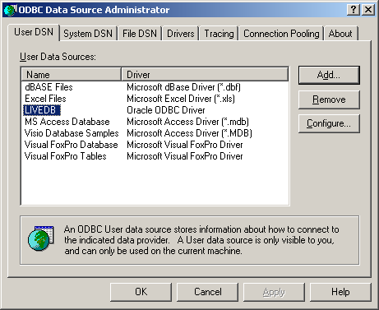

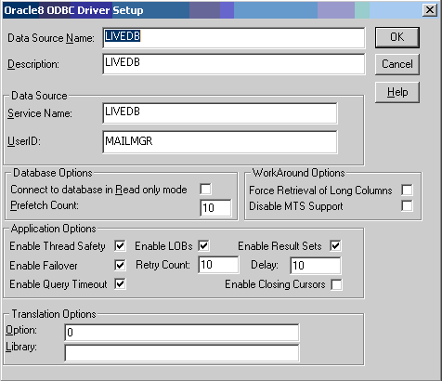

Configuring MDB
- Open C:\IBAEHIS\SMTMLSRV\SMTMLSRV.MDB
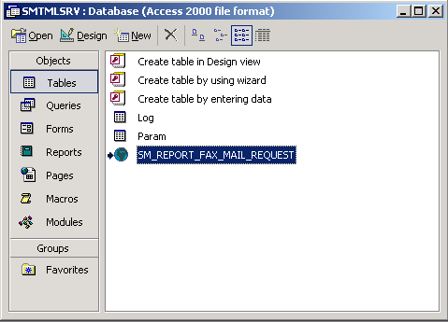

- Delete SM_REPORT_FAX_MAIL_REQUEST
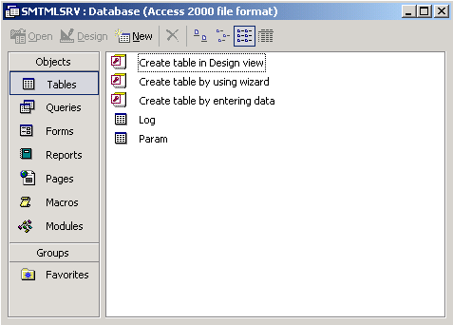
- In Tables, right-click and select “Linked Tables”.
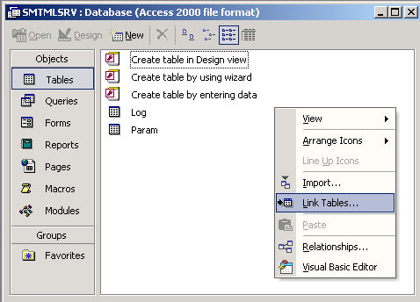

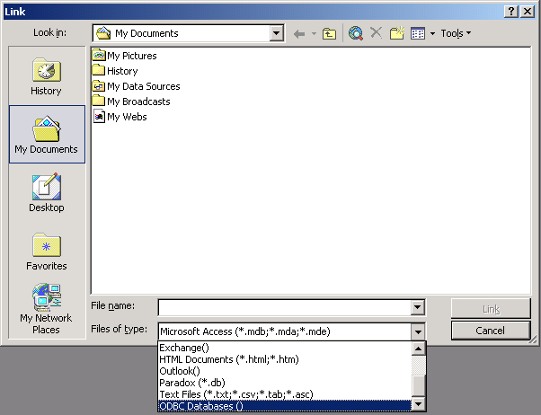
- Select ODBC DSN (Example LIVEDB)

- Supply password (Example MED123) and click OK
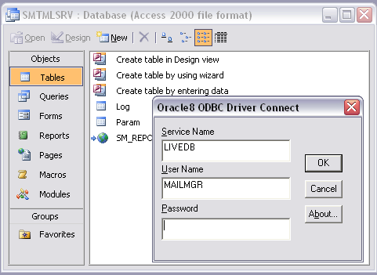
- Select IBAEHIS.SM_REPORT_FAX_MAIL_REQUEST.
IMPORTANT: Check “Save password”

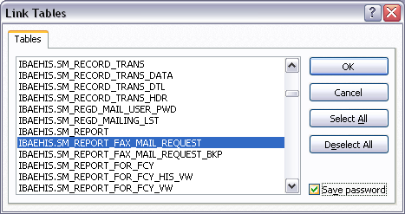

- Select REQUEST_SRL_NO as Unique record identifier (If this screen prompts).

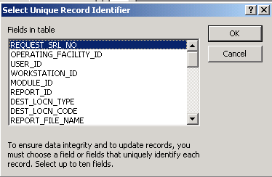

- Table is linked. Name is IBAEHIS_SM_REPORT_FAX_MAIL_REQUEST
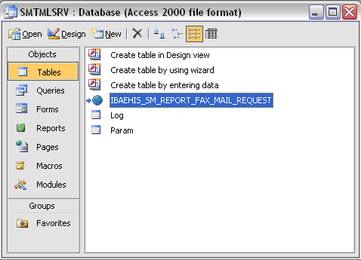

- Right click IBAEHIS_SM_REPORT_FAX_MAIL_REQUEST and rename as SM_REPORT_FAX_MAIL_REQUEST
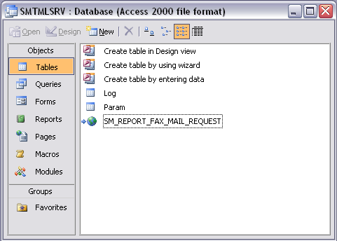

Setting up Parameter for IBA Email Service

IBA Email Service parameters can be modified to suite the installation requirements at site. These parameters are stored in the Access database for easy modification at site. In the IBA_EMAIL_GATEWAY system, do the following to configure the parameters.

Open the ‘SMTMLSRV.MDB’ file from ‘C:\IBAEHIS\SMTMLSRV’ sub-directory by double clicking. To view / modify the supplied parameters, open the ‘Param’ table. Following table lists the parameters that are supplied.

ID | Value | Description
Connect String | uid=emailuser;pwd=email123;driver={Oracle ODBC Driver}; | Uid – Valid IBA database username  Pwd – Password for the above user  Driver – Driver name used while configuring ODBC
DSName | LIVEDB | Data source name of ODBC configuration
ProfileName | lismailsdg | Email profile name which IBAeHIS Email Service will use to login and send email messages.
TestMailID | Any valid mail id | Test mail can be sent by double-clicking the version number which is appearing on IBA Email Service screen. Test mail will be sent to this mail id.
TestMailCcID | Any valid mail id | Test mail is sent to this mail id (Cc field)
TestMailBccID | Any valid mail id | Test mail is sent to this mail id (Bcc field)
TestMailAttachment | File name with full path | Test mail will be sent with this attachment.  Example: C:\Temp\Test.PDF
TestMailSubject | Mail Subject | This value will be used as Subject when sending test mail
TestMailText | Mail text | This value will be used as mail body when sending test mail

Example ‘PARAM’ table entry
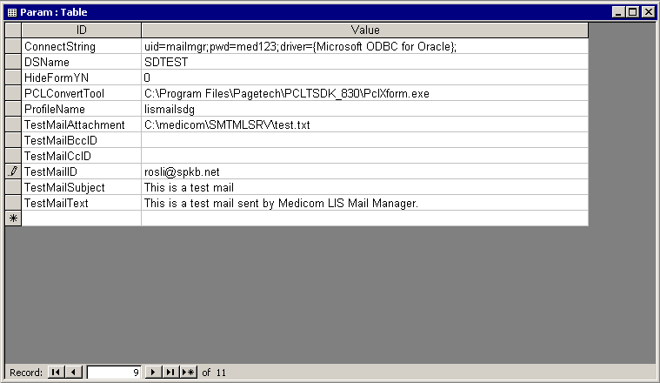
Figure 5-2

Start the Mail Service

- Mail Server should be started logging into IBA EHIS 2 Tier → System Manager → Process Management → Administer Server Process
- Select the Mail services process and select the facility, priority and serviced requests parameters for the process and press the start button for starting the process

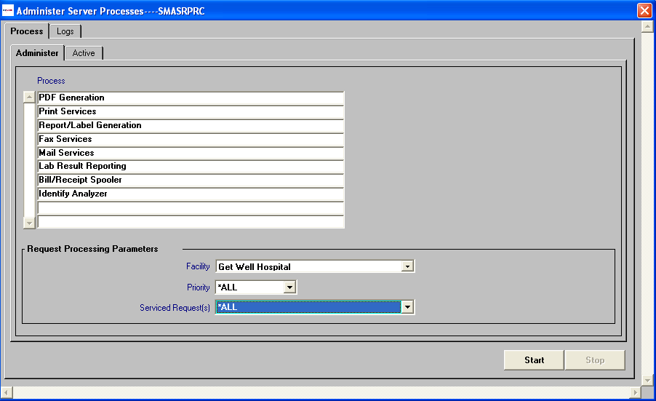
Mail Service

- Once the process is started it can be seen in Active tab of Administer Server Process; upon selecting the process from list item it will show the workstation in which this process is started and other details as shown in the below screenshot
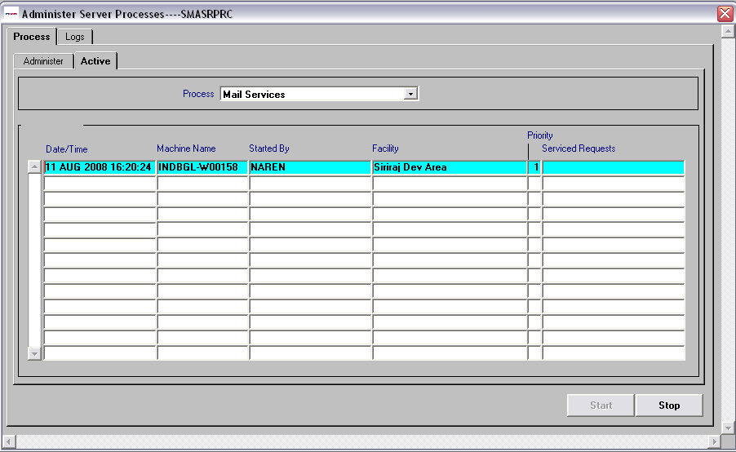

Note: Any changes in the parameter table (‘Param’ of SMTMLSRV.mdb) while the ‘Mail Services’ is running will be in effect only after restarting it.

Test Mail through Mail Manager Service window
- Edit the ‘Param’ table, set ID ‘HideFormYN’ value as ‘0’. This shows the Mail Manager Service window when you start the ‘Mail Service’.

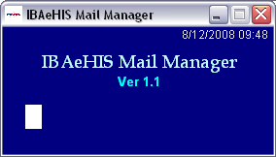

- Double click on the ‘Ver 1.1’ to send the test mail.

PDF Creation Utility Installation and Configuration

Installation requirement for PDF Creation Utility

Ensure JDK 1.5 or above and Forms Runtime is installed in IBAEHIS_EMAIL_GATEWAY system.

Setting up Environment Variables

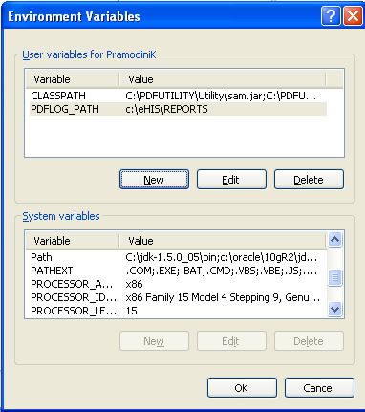
JDK and Pro*C path
Jar files Path
PDF Log output directory path

Setting the Class Path:

- Create a directory PDFUTILITY in IBAEHIS_EMAIL_GATEWAY system C:\ drive.
- Copy the following PDF Creation Utility JAR files into C:\PDFUTILITY directory.
- specify the JAR files in environment variables CLASSPATH as shown in the above screenshot; ex: C:\PDFUTILITY\Utility\sam.jar;C:\PDFUTILITY\Utility\IBAPdfUtility.jar;C:\PDFUTILITY\Utility\iText-2.0.8.jar;C:\PDFUTILITY\Utility\bcprov-jdk14-138.jar;C:\PDFUTILITY\Utility\log4j.jar

Note: incase you want to copy PDF Utility JAR file into a different directory, you can do it, for this you need to specify the same directory in the JAR file path.

Setting the PDF Log Path:

- Create a directory for PDF log files; it would be better if the Report Output directory (PDF Creation Directory) and Log file directory are same for easy management.
- Ensure logged in windows user has the read / write privilege on PDF log directory.
- Specify the PDF Log directory in environment variables PDFLOG_PATH as shown in the above screen shot; ex: c:\eHIS\Reports.

Setting the JDK and Pro*C path:
- Specify the JDK Path and Pro*C path in environment variables PATH as shown in the above screen shot; ex: c:\jdk-1.5_05\bin;o:\proc;

Configuring ODBC

ODBC connection should be created to acquire database connection.

- Go to Control Panel -> Administrative tools -> Data Source (ODBC). Double Click on Data Sources (ODBC)

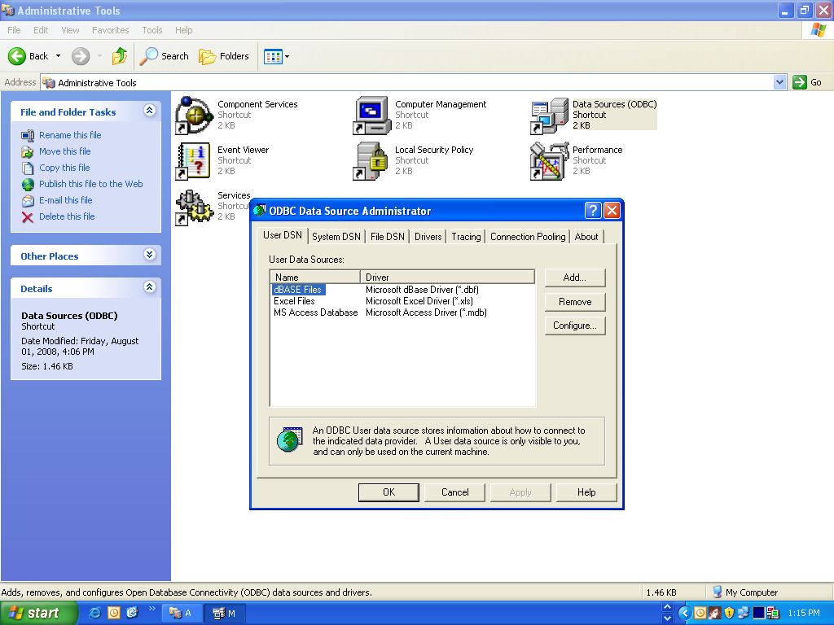

- Select “User DSN” tab You get a window as shown above
- Click Add button. The following screen will appear

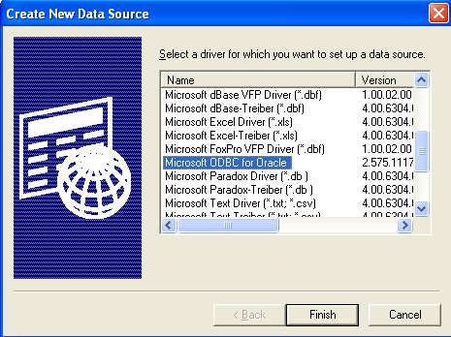

- Select Microsoft ODBC for Oracle from the list. And click Finish. You will get a screen shown as below

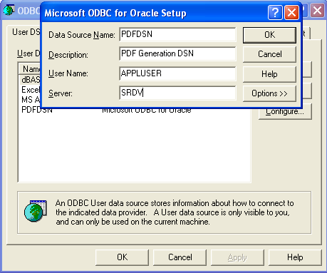

- You need to enter the values as below:

Parameter | Value to be Given | Remarks
Data Source Name | PDFDSN | Same Value should be specified as it is used internally in application.
Description | PDF generation DSN | Optional, can give a brief description.
User Name | APPLUSER | Same Value should be specified as it is used internally in application.
Server | <Database Connect String> ex: SRDV | Database Connect String value should be specified in this.

- Click Ok. You will get a screen shown as below which lists the DSN that we have created

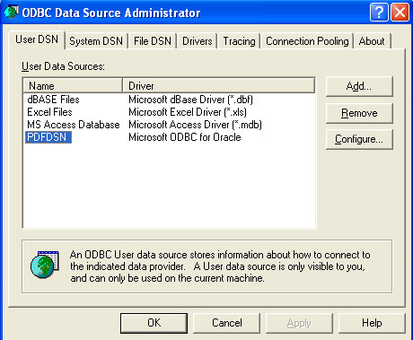

Workstation Parameters configuration

Specify the PDF file output directory in IBA EHIS 2 Tier → System Manager → Report Management → Setup → WorkStation Based Print Routing / Parameters.

Specify the parameter value for Report Output Directory variable. Refer the below screenshot.
Ex: W:\SM\PdfFiles\ (it is mandatory that the value should end with ‘\’)

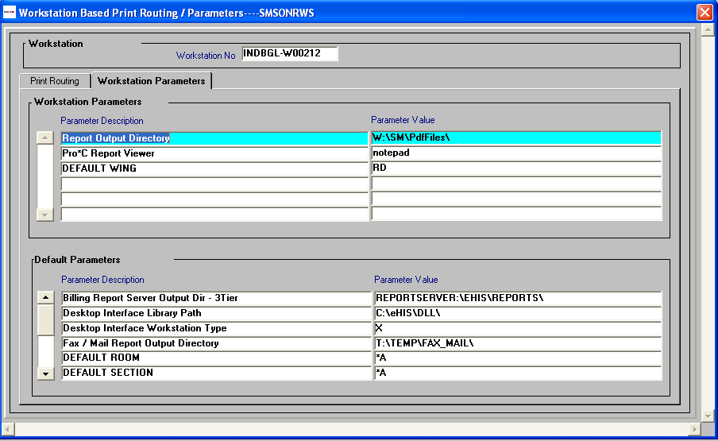
Report Output Directory

PDF Creation Utility Process Starting

- PDF Creation Process should be started logging into IBA EHIS 2 Tier → System Manager → Process Management → Administer Server Process

- Select the PDF Generation process and select the facility, priority and serviced requests parameters for the process and press the start button for starting the process

PDF Generation Process

- Once the process is started it will invoke SMTFXPDF.EXE for processing the PDF request. This will be listed under the Windows Task Manager → Process tab

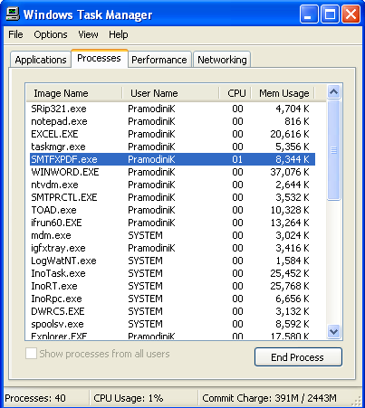
PDF Server Process

- Once the process is started it can be seen in Active tab of Administer Server Process; upon selecting the process from list item it will show the workstation in which this process is started and other details as shown in the below screen shot.

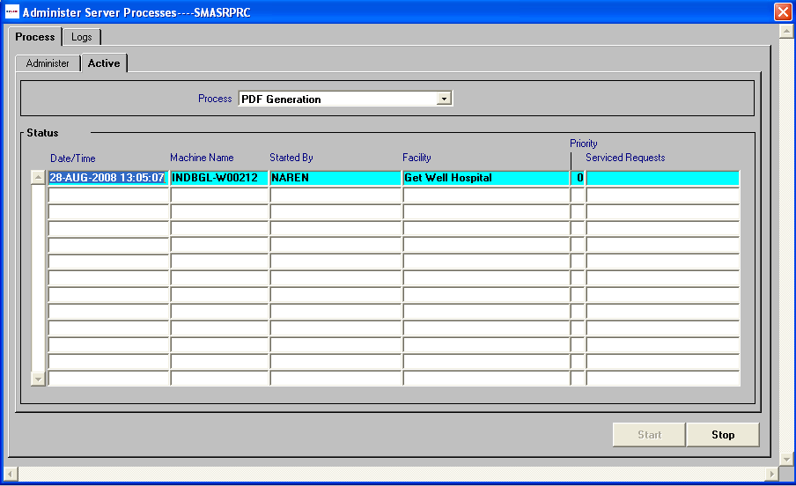

PDF Creation Utility Trouble Shooting

PDF Log file
- PDF server process will create a log file under the specified location for PDFLOG_PATH variable of environment variables
- Under the above PDFLOG_PATH file location, PDF utility will create a folder with name PDFLOG. This folder contains the log files created day wise. A text file with format pdf_err_dd-mm-yyyy.txt will be created. Ex: pdf_err_28-08-2008.txt
- This text file will give us the success/failure status of the PDF file creation. In case of failure, it logs the appropriate error messages for further analysis.
- Make sure the user has access privileges to create the files under the specified output directory for log file creation.

PDF Process Sleep time:
- The background process will continuously check for the pending requests by fetching the records from PDF Request table. A sleep time of 3 secs is defined for the PDF process.

Trouble shooting:
- As the PDF process is a continuous process, any interruption which causes the process to stop executing, should be taken care. If there is database / network connection failure/interruption, the process stops executing. In such cases once the connection is restored, the process should be restarted.
- PDF file creation will give ‘ORA-01722: invalid number’ error and the PDF file will not be created if the file name contains any ‘blank spaces’ in between. ‘Blank spaces’ in the file name should be avoided to overcome this error.

